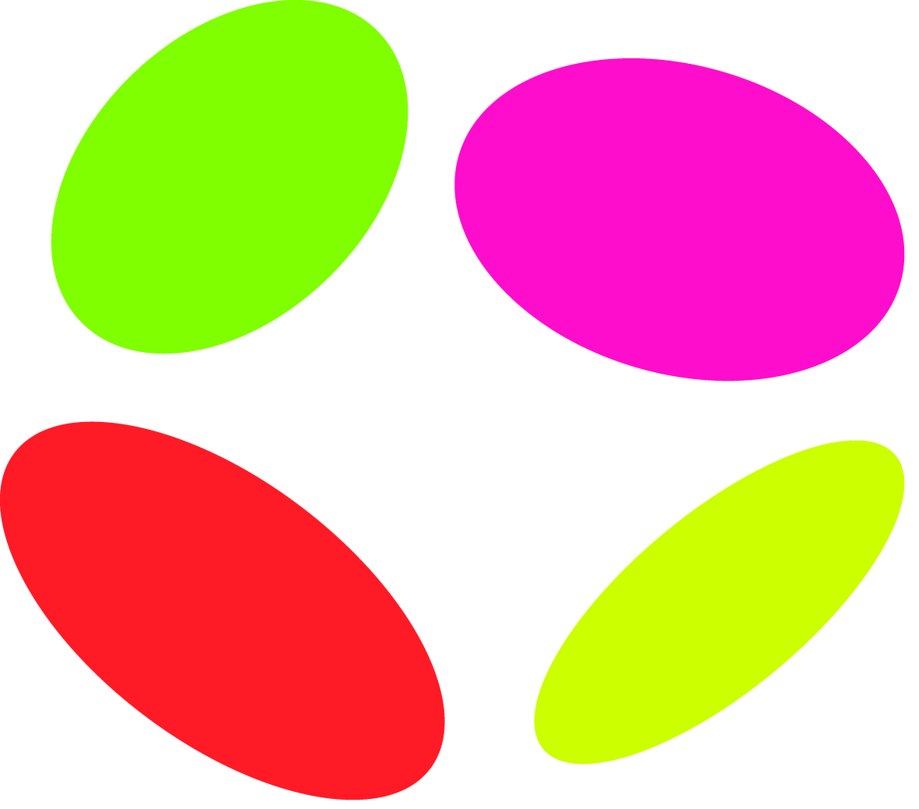
Chelsea Community Hospital School
Students with Medical and Mental Health Needs
Referral Form
A referral from Westminster or Royal Borough of Kensington & Chelsea can be made by any professional involved with the student.

All information requested is essential to ensure that all student needs are identified and considered at the earliest possible stage in the referral process.

The aim of this referral form is to provide information for discussion at an initial professionals’ meeting to decide whether CCHS is best placed to meet the student’s needs.

If a decision is made to proceed, the student, parents/carers and the key contact in the community will be invited to a meeting. At this meeting a timetable will be discussed and agreed for an initial 6-week period. This could be a joint timetable with the home school, individual tuition at home or a placement at the Ladbroke Grove Site.

Reviews will be held every 6 weeks and the referrer, parents and student will be invited to these meetings.

CCHS will only rarely be a permanent placement for a student, the aims of the placement will be decided individually, however we hope to set goals and work with the family, home school, medical/mental health team and LA to support the student returning to school.

When it is decided that CCHS should be a permanent placement, usually for KS4 students, we will work with the Local Authority to ensure they have an EHCP which provides the additional support needed.

REFERRER DETAILS
Referrer: |  |  |  |  |  |  |  |  |  |  |  |  | Profession:
Address: |  |  |  |  |  |  |  |  |  |  |  |  | Phone:  Email:
Date of this referral:

STUDENT AND FAMILY DETAILS
Name of Student: |  |  |  |  |  |  |  |  |  |  |  |  | DOB |  | Year group
Parent / Carer Name:  Relationship to child: |  |  |  |  |  |  |  | Phone:  Email:
Parent / Carer Name:  Relationship to child: |  |  |  |  |  |  |  | Phone:  Email:
Home address:

Postcode:
Students first language:  If this is not English, please indicate current level of English: |  |  |  |  |  |  |  | Main language spoken at home:
Who has parental responsibility?

STUDENT STRENGTHS
Please tell us about the student’s strengths, interests and aspirations

SCHOOL DETAILS
Current or last (if off roll) school:
Address:

Date last attended school:  Are there attendance concerns? |  |  |  |  |  |  |  |  |  | Attendance % for current year:  Attendance % for previous year:
Is this pupil on the special needs register? Yes/No  If yes, please outline needs: |  |  |  |  |  |  |  |  |  | Does the pupil have an EHC Plan?  Yes/No
 |  |  |  |  |  |  |  |  |  | If yes, please attach a copy.
School contacts:
Headteacher: |  | Phone:  Email:
SENCo |  | Phone:  Email
Head of Year |  | Phone:  Email
School EWO |  | Phone:  Email
ACADEMIC INFORMATION
(Please provide as much information as possible and attached a copy of the last school report)
Current NC levels  (if applicable) |  |  |  | Please provide details of KS4 courses being studied (if relevant).
English: |  |  |  | Subject |  | Course Type |  |  | Exam board |  |  |  |  | Current grade/level |  | Target grade
Maths:

Science:

Current reading age

KS3 CAT Scores:
Mean Score:

Verbal  SAS | Quant  SAS |  | Non Verbal  SAS
MEDICAL/CAMHS INVOLVEMENT

Name of Medical/ CAMHS Consultant: |  |  |  |  |  |  |  |  |  |  |  |  | Phone:  Email:
Name and address of hospital department or CAMHs service |  |  |  |  |  |  |  |  |  |  |  |  | Email:
Details of condition preventing attendance at school:

(A letter containing further information should be received from the medical/mental health team)
SOCIAL CARE INVOLVEMENT
Allocated Social Worker: |  |  |  |  |  |  |  |  |  |  |  | Phone:  Email:
Is the young person a LAC? Yes/No  If yes, which local authority has responsibility?  Key Contact: |  |  |  |  |  |  |  |  |  |  |  | Phone:  Email:
Is the young person on the Child Protection Register? Yes/No
Under which category:
What are the main areas in the Child protection Plan?

Is the young person a Child in Need (CiN)? Yes/No
What are the main areas on the CiN plan?

Is the family open to Early Help? Yes/No
What is their involvement.

CURRENT RISKS
(Please attach copies of any relevant risk assessment and/or support plan)
Risks to self (e.g. self-harm, suicidal ideation, drugs, offending, bullied) |  |  |  |  |  |  | Mitigation measures
Risks to others (e.g. bullying, challenging behaviour) |  |  |  |  |  |  | Mitigation measures
DETAILS OF OTHER AGENCY INVOLVEMENT
NAME |  |  |  |  | AGENCY |  |  |  |  |  | CONTACT DETAILS
Phone:

Email:
Phone:

Email:
Phone:

Email:
Phone:

Email:
Phone:

Email:
Phone:

Email:
PARENTAL/CARER AGREEMENT

Are parents/carers aware of this referral? Yes/No
Are parents/carers supportive of this referral? Yes/No
RETURN DETAILS
For the attention of the referral team
referrals@cchs.org.uk

